AGENDA
Fish Passage Operation and Maintenance (FPOM) Team meeting
October 11, 2012 (0900-1430)
St. Helen’s Room (10th floor). NOAA Fisheries, Portland, OR.
Conference line: 888-675-2535 FPOM code: 4849586

- Approve September 2012 FPOM minutes. (Klatte)

- Action Items
  - NWW Action Items
    - [Sep 12] NWW Transport. ACTION: John Bailey will notify Bettin of the release schedule.
  - NWP Action Items
    - [Sep] AQS-20E. ACTION: NWW will find out more information about the anesthetic used at LWG and bring it back to the October FPOM.
    - [Sep] AFF Task Group. ACTION: Klatte will follow up with Programs about getting a PM and getting work started prior to the start of the 2013 adult studies.
  - Action Items completed or to be discussed later in the agenda.
    - [Sep 12] NWW LWG winter maintenance. ACTION: Moody will ask LWG about adding two weeks at the end instead of in December. Setter said she would find out more about the lamprey ramps to see if they could be delayed until the 2013-14 winter maintenance season. STATUS: to be discussed under Coordination Forms.

- Updates
  - NWP Updates
    - JDA trash rake crane.
    - JDA-N fish passage numbers.
    - TDA spillbay 9 trunnion pin.
    - BON Spillbay 15 hoist. Update on repairs.
    - BON Unit 11 status.
    - BON B-Branch update.
    - NWP winter maintenance schedules. These are posted to the website.

  - NWW Updates
    - Transport.
    - DWR – Unit 2 unwatering 18 September 2012 update on procedure.
    - LWG - Elevated descaling reported at the JFF / actions to reduce it.
    - LWG - adult fishway outage for diffuser grating replacement.
    - LWG – adult trap anesthetic – set aside for later FPOM meeting.
    - LGS – AUX #3 Status.
    - LMN – raceway perforated plate tail screen.
    - IHR – South Fish Pump #4.
    - MCN - Debris Spill.

  - Research/FFDRWG updates. Approval letters, permits, etc located at www.nwd-wc.usace.army.mil/tmt/documents/FPOM/2010/NWP%20Research/Research.html
    - BON BI/CI Phase II EDR. Entire EDR is available on the FPOM website for the October 2012 meeting. The Summary was sent with the FPOM agenda.

  - RCC update.
Project | Current (kcfs) | 5 day forecast (kcfs) | 10 day forecast (kcfs)
LWG
MCN
BON

  - Lamprey updates.
    - Proposal by FFU for counting window modifications.
    - MCN SFE2 – current deep slot and prototype design
    - NWW mods for lamprey passage – completed and upcoming
  - Avian Hazing.
    - NWW bird numbers before and after spill
    - MCN hydrocannon pump
    - MCN avian wires
    - APHIS hazing schedule at NWW projects for 2013.
  - BPA updates.

- Coordination/Notification forms (need concurrence).
  - 12BON36 BON spillway rock removal
  - 12JDA22 JDA-N dive inspection.
  - 12MCN010 – removal of hydroacoustic transducers
  - 12IHR012 – JSATS tracking
  - 12LWG013 – early unwatering of fish ladder

- 2013 FPP change forms.

- Potential 2013 FPP change forms
  - BON turbine ops table. Include open geometry. Tables are currently being reviewed prior to release.
  - BON PH1 gatewell dewatering protocols (re: juvenile mortalities on Unit 6 headgate).
  - BON Appendix A – PH2 slot filler unit priority change.
  - JDA 2.4.1.2.g orifice position for dewatered turbine units.
  - Update FPP language to clarify what unit priority means.
  - MCN trash rack inspections and raking.
  - 12 LMN05 summer spill change. Need to look at hydraulic data from R. Laughery.
  - Incidental species appendix. May include lamprey, sturgeon, etc. NWW will take the lead on starting this appendix.

- Task Group Updates.
  - Sturgeon task group (Van der Leeuw or Hausmann). Next meeting will meet after the October FPOM meeting. Parsley will give a powerpoint presentation at the end of FPOM and be followed by the Task Group meeting.
    - Hausmann requested this task group be disbanded since it seems to be a route for researchers to attempt to access the project for research purposes rather than assist in improving conditions for sturgeon in the turbine environment. Fredricks asked about the slow roll process. Hausmann said it’s being implemented but will take time getting the governors reprogrammed. Fredricks said before that is complete, he and Rerecich have been talking about looking at the slow roll conditions at ERDC. The group going to ERDC will look at flows and what happens in the draft tube during the slow roll process.
  - BON unit operating range (Lorz). Had a call on 12 September. Members have their assignments and will need to provide a write up to include in a larger document (formatted similar to Fredricks’ memo)
    - Team members present included Baus, Benner, Bettin, Chockley, Conder, Cooper, Fredricks, Hausmann, Hevlin, Lorz, Mackey, Meyer, Tackley, Rerecich, Wills.
    - Lorz assigned the 9 concerns, plus 1 data request, presented in Fredricks’ draft document.
- Second powerhouse gatewell fish condition test results from 2008 – 2009. Fredricks.
- Past (<2007) and recent (2010 – 2012) Smolt Monitoring Program data and observations. FPC and Conder.
- Second powerhouse gatewell debris/turbine loading/fish condition relationships. Hausmann.
- Second powerhouse turbine unit passage and survival considerations. TSP group
- NERC generations flexibility requirements and AGC programming schedule. Bettin/NWP. Completed.
- First powerhouse open geometry MGR unit operation. Fredricks Completed.
- Adult passage concerns – spillway approach and Bradford Is. fallback. Benner
- Total dissolved gas concerns. Fredricks/Kruger Baus will write a paragraph analogous to the 1% justification for operating PH2 units at the mid-point. Bettin said BPA needs good justification for de-rating the units. Everyone agreed this work will provide that justification.
- Gatewell Improvement Program alternatives and schedule. Rerecich
- HDC open geometry tables and associated costs with PH1 open geometry and PH2 mid-point operation. Mackey Tables will be available at the end of September.
- Lamprey and Bull trout data. FPC agreed to take on juvenile lamprey data.
- BON PH2 units used as spinning reserve. Bettin
    - Rerecich reported that he has been talking with PNNL about looking at open geometry v 1% at PH1 and low v high 1% at PH2.
    - Check in call/meeting in October.
  - BON VBS task group. (Hausmann). Met after the BON Ops TG on 9 August. Attendees included Baus, Bettin, Fredricks, Hausmann, Lorz, Mackey, Rerecich, and Wills. Fredricks said the main purpose it to better clarify the FPP criteria for re-installing screens and how to keep screens in throughout the year.
    - Hausmann provided a handout for discussion. Lots of discussion took place in little groups. Eventually discussions focused on one discussion with the entire group. Fredricks said he would like to see ideas that are out of the box. Lorz and Meyer suggested rotating louvers.
    - Fredricks said the second reason for this group is to look at the screen installation trigger. Hausmann will look at the spring data to see when screens would have been reinstalled in 2012.
    - Wills said he really likes Fredricks’ comment during FPOM- to pull Unit 11 and replace with the new, improved, fish friendly turbine and then pull the screens. Bettin said the problem is that we are not currently using the PH1 MGRs to their full capacity. Fredricks said PH1 isn’t as fish friendly as the new design. Bettin said if you can prove that the change will pencil out for BPA, then you will get support.
    - Fredricks said 1% will not be in the new BiOp and even the current one says to operate for best fish survival.
    - BON PH2 units used as spinning reserve was brought up. The group agreed this should be explored more, especially if an agreement can be reached by all parties.
    - Fredricks would like to look debris pre-FGE improvements and post-FGE improvements.
    - Discussion about pulling screens out of BON. Bettin noted that if screens were pulled at BON, then TDA and BON could be safer for lamprey. Fredricks noted he doesn’t like BON screens but we need to look at survival. Everyone agreed there is a need to look at the 2012 data.
  - AFF mods (Rerecich). Rerecich reported that a charter has been written and has been routed. Waiting for a PM to be assigned. Expect CRFM funding with construction anticipated for FT13. Fredricks would like to have input in the process at the 30%, etc. Fredricks expressed his concern about the delays. Lorz said if the AFF isn’t modified, then CRITFC isn’t going to approve the adult studies for 2013. ACTION: Klatte will follow up with Programs.
    - Near-term projects:
      - Install a new floor in the recovery pool area to hold up a new two stage recovery tank. Extend the exit section of this new tank well upstream of the drain grizzly.
      - Evaluate potential to improve drain grizzly hydraulics to even out flow distribution.
      - Extend the return to ladder flume pipes out of the existing building (perhaps with another 90 degree bend around corner of the building).

  - Fish counting task group (Setter). The team will meet after the January 2013 FPOM.
    - Team members include Fredricks, Klatte, Mackey, Setter, Tackley, and Wills. Discussions will include when and what to count. This group will explore ways to save money on the fish count contract. The group will look at both lamprey and salmon. Conder asked if money is saved on fish counting, can the money be spent on other improvements. Due to the budget cuts coming, any savings would just keep the fish program in the black. Fredricks said there are a lot more details needed. He said that there would be more enthusiasm if the cuts resulted in money getting moved to other fish projects, but if it just gets cut and it gone, that is just a shrinking of the program.

- Calendar sync.
Northwestern Division – U.S. Army Corps of Engineers
ANADROMOUS FISH EVALUATION PROGRAM
FY13 RESEARCH SUMMARY

STUDY CODE:

TITLE: Fishway Counting Slot Modifications to Improve Lamprey Night Passage and Counting Accuracy at Bonneville Dam

FISH PROGRAM FEATURE: FCRPS – Bonneville Adult Passage at Night.

BIOLOGICAL OPINION ACTION: RM&E Action 3 – Monitor and Evaluate Fish Performance within the FCRPS.

MANAGEMENT PURPOSE: Improve adult Pacific lamprey night passage and counting accuracy at Bonneville Dam. Determine if window cleaning, lighting, and flow modifications can be made to the counting slots in the adult fishways to reduce lamprey confusion. Improvements may be applicable to upriver FCRPS counting slots.

SUMMARY: Adult lampreys have a difficult time passing the counting slots at Bonneville Dam. The portions of down counts in the 2009, 2010, 2011, and 2012 (to about 8/20/2012) night lamprey counts at Bonneville are high compared to those at The Dalles, John Day, McNary and Lower Granite (Table 1). Adult passage efficiencies are often less than 50% at Bonneville Dam (“Passage Efficiency of Adult Pacific Lampreys at Hydropower Dams on the Lower Columbia River, USA”. Moser, Ocker, Stuehrenberg, and Bjornn. TAFS 131.956-965, 2002.). In the summer of 2011, of 85 Pacific lamprey collected at Bonneville Dam, JSATS and HD-PIT tagged, and released back into the tailrace, the escapement estimate to past Bonneville Dam was 35% (“Adult Pacific Lamprey Migration Behavior and Escapement in the Bonneville Reservoir and Lower Columbia River Monitored Using the Juvenile Salmonid Acoustic Telemetry System (JSATS), 2011”. Noyes, Caudill, Clabough, Joosten, Johnson, Keefer, and Naughton. Technical Report 2012-4-draft USACE Portland, 2012.). In the summer of 2010, of 312 lampreys tagged, 126 (40%) passed Bonneville Dam (“General Passage and Fishway Use Summaries for Adult Pacific Lamprey at Bonneville, The Dalles, and John Day Dams, 2010”. Clabough, Johnson, Keefer, Caudill, and Moser. Technical Report 2011-5-draft USACE Portland, 2011.). Clabough, Johnson, Keefer, Caudill, and Moser identified fishway entrances, transition pools, counting windows, and serpentine weir sections of fishways as locations where lamprey have difficulty passing and wrote, “mechanisms for fishway passage failure remain poorly understood but likely are related to a combination of operational and structural challenges that include high water velocity and turbulence, sharp-edged steps and corners, poor attachment surfaces (i.e., at diffusers), and confusing attraction cues.”.

Table 1. Numbers of Pacific Lamprey Counted Passing Up and Passing Down in the Counting Slots at Night (starting June 15 each year at Bonneville (BON) and Lower Granite (LWG); starting July 1 each year at The Dalles (TDA), John Day (JDA), and McNary (MCN); ending September 30 at all dams in 2009-2011; ending to-date (August 25) this year).

 | BON BI | BON WS | TDA E | TDA N | JDA S | JDA N | MCN S | MCN N | LWG
2009 up | 46,641 | 85,253 |  |  |  |  | 546 | 232 | 70
2009 down | 40,379 | 85,866 |  |  |  |  | 97 | 15 | 3
2010 up | 25,406 | 95,964 |  |  |  |  | 281 | 99 | 83
2010 down | 21,250 | 86,685 |  |  |  |  | 30 | 5 | 6
2011 up | 100,193 | 242,715 |  |  |  |  | 300 | 253 | 278
2010 down | 90,571 | 233,480 |  |  |  |  | 30 | 1 | 19
2012 up | 242,597 | 434,287 | 7,431 | 6,407 | 3,502 | 2,584 | 393 | 171 | 177
2012 down | 222,970 | 412,755 | 2,117 | 1,215 | 874 | 453 | 23 | 3 | 4

Non-uniform counting slot passage, illustrated in these numbers, may negatively affect lamprey night counting accuracy at Bonneville.

Finally, an unknown portion of the lampreys at Bonneville swim through the counting slots along the bottoms of the slots, unseen against the dark floors.

OBJECTIVES: Evaluate means to improve lamprey counting accuracy and passage efficiency at night by modifying fishway lighting in and upstream of the counting slots, straightening and shortening flow paths in the transition pools just upstream of the counting slots, and developing counting window, crowder, and counting slot floor cleaning strategies. Use improvements to develop counting slot criteria that can be applied to all the counting slots in FCRPS fishladders in the river basin.

The current Fish Passage Plan for FCRPS fishladders lacks detail in four areas concerning counting slots, two that may fall within the scope of O&M funding: 1. lighting and 2. cleaning; and two that may fall within the scope of CRFM funding: 3. flow path and 4. night video.

1. Lighting
Some Pacific lamprey may become disoriented and their upstream passage slowed, stopped, or reversed by the artificial light entering fishway water from the fish counting windows and from visitors’ center fish viewing windows. At Bonneville, the visitors’ center fish viewing windows lie just upstream of the fish counting slots. Smooth upstream passage may also be disrupted by the lack of over-water light that lamprey may need to maintain surface orientation. The fishway upstream of the counting slots at Bonneville lie underneath large building overhangs, a situation unique to Bonneville. A combination of light entering the fishladders from viewing windows coupled with low overhead light may confuse some Pacific lamprey. Pilot studies have shown that simply turning down the lights in the count station and blocking light from the upstream visitors’ windows reduced up-down swimming of lamprey and facilitated more uniform upstream passage. These pilot studies should be expanded to develop FPP criteria.

2. Cleaning
At the present time the Fish Passage Plan contains no cleaning criteria and/or cleaning schedules for the counting slot windows, lower windows, floors, or crowder faces. Typically the fish counters working in the fish counting stations are free to operate mechanical cleaning brush systems as often as they like to clean the fish counting windows in the counting slots, and typically they keep the counting windows very clean. However, they must rely on project personnel to clean the lowest few inches of the counting windows closest to the floors of the counting slots that the cleaning brushes don’t reach (where many lamprey pass) and to clean removable crowder face panels. The floors of the counting slots are never cleaned.

3. Flow Path
Some Pacific lamprey (and salmon) would likely benefit from the addition of orifices to the transition pools that lie just upstream of the counting slots at Bonneville, to create straighter and shorter flow paths for fish to follow.

4. Night Video
FFU has been working with infrared lighting and infrared-sensitive cameras, to improve video quality and night video’s impact on Pacific lamprey. From points directly above the counting slots, infrared light can be used to see fish clearly to 127 cm (50 in) below the surface of the 152.4 cm (60 in) deep counting slot water columns at Bonneville Dam. A combination of infrared and red light may make the entire slot visible through the infrared-sensitive cameras. Replacing the floor of the counting slots with a hollow metal or glass floor with infrared LED lights mounted in the hollow space that radiate light up may also make the entire slot visible through infrared-sensitive cameras.

SCHEDULE: 2013.

CONTACT: John Dalen (541) 374-8801 [August 25, 2012, draft 2]
OFFICIAL COORDINATION REQUEST FOR
NON-ROUTINE OPERATIONS AND MAINTENANCE
☻☻☻☻☻☻☻☻☻☻☻☻☻☻☻☻☻☻☻☻☻☻☻☻☻☻☻☻☻☻☻☻☻☻☻☻☻
☻☻☻☻☻☻☻☻☻☻☻☻☻☻☻☻☻☻☻☻☻☻☻☻☻☻☻☻☻☻☻☻☻☻☻☻☻
COORDINATION TITLE- 12BON36 BON Spillway rock removal.
COORDINATION DATE- 4 October 2012
PROJECT- Bonneville Dam
RESPONSE DATE- 11 October 2012

Description of the problem- Contract has been awarded to repair erosion holes in the Bonneville Spillway. Currently no special operations are required. A daily conference call will occur at 1:30 between RCC, BPA, Bonneville Project, Construction Office and the Contractor to inform the contractor of expected conditions for the next 24 hours, 48 hours etc. If the contractor has any special request it will be discussed during the conference call.

Emergency spill procedures are in place/documented in the Plans and Specs but the goal is to not have to spill during the contract.

Currently trying to negotiate an early start date to be able to have the contractor remove rocks from the stilling basin. Contractor could move in as early as 22 October but no later than 1 November. Work will take up the majority of the in-water work window.

Type of outage required- BON spillway, except Bays 1 and 18 which are used for attraction flow, will be out of service about a week earlier than previously coordinated.

Impact on facility operation- The spillway will be out of service for an additional week. Avian wires will need to be removed a week earlier than originally planned.

Dates of impacts/repairs- As early at 22 October 2012.

Length of time for repairs- Possibly up to a week for rock removal. Spillway repair then begins on 1 November.

Expected impacts on fish passage
Downstream migrants- No impacts expected.

Upstream migrants- There may be impacts to upstream migrating salmonids and lamprey, using the Cascades Island fishway entrance (B-Branch will likely remain OOS during this operation). Impacts are likely to be noise disturbance associated with the rock removal.

Even with these impacts, removing the rock is a critical step in repairing the spillway.

Table 1. Average fish (Chinook, steelhead, coho, chum) passage at BON from 22 – 31 October 2007 -2011.
Date | 10/22 | 10/23 | 10/24 | 10/25 | 10/26 | 10/27 | 10/28 | 10/29 | 10/30 | 10/31
Average passage | 1874 | 1378 | 1336 | 1059 | 883 | 1166 | 821 | 716 | 825 | 712

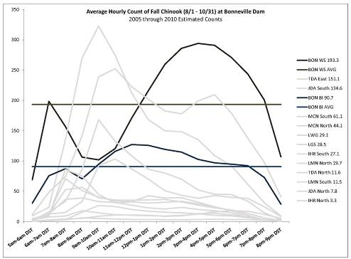
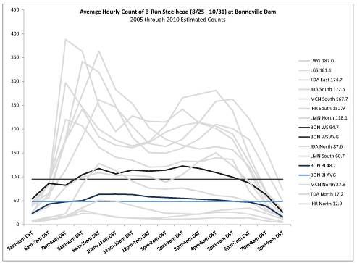
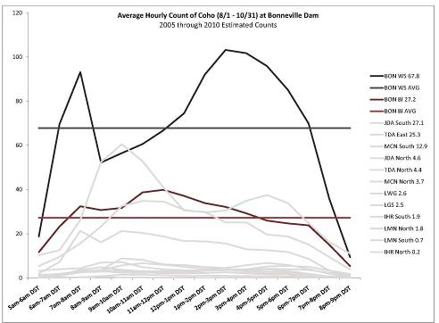
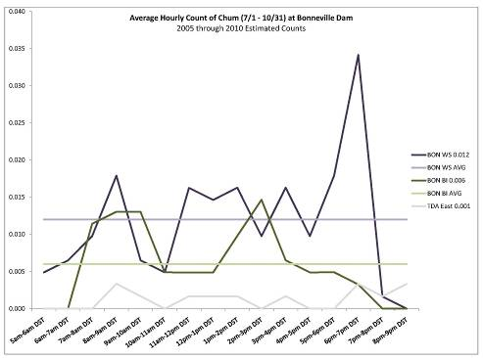
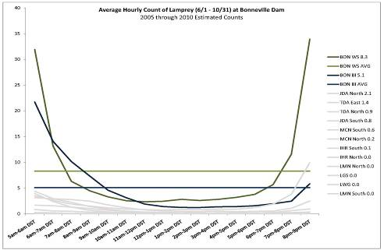

Comments from agencies
04 October 2012 NWP FFDRWG- The FFDRWG attendees were in favor of getting the rocks removed and recommended this request go to the 11 October 2012 FPOM.

Final results
☻☻☻☻☻☻☻☻☻☻☻☻☻☻☻☻☻☻☻☻☻☻☻☻☻☻☻☻☻☻☻☻☻☻☻☻☻
COORDINATION TITLE- 12JDA22 JDA-N Dive inspection
COORDINATION DATE – 13 September 2012 (FPOM)
PROJECT- John Day Dam
RESPONSE DATE- 11 October 2012 (FPOM)

Description of the problem – Due to fishway entrance undermining, the JDA North Fish Ladder (JDA-N) entrance improvements contractor requests an inspection of the JDA-N entrance. Two previous ROV inspection attempts failed. Divers will now be used. The dive is scheduled for 23 October 2012.

The information from the entrance inspection will be used to inform design decisions for JDA-N entrance improvements (2012-2013 IWW period).

Type of outage required- The north AWS fish pumps will be off. Spill bay 2 will be closed.

Impact on facility operation – This operation would take the north fishway out of FPP criteria, however, the goal is to overlap this dive inspection with PNNL hydrophone removal.

Dates of impacts/repairs –JDA-N operations will be impacted for about 10 hours on 23 October. This includes PNNL hydro phone removal and JDA-N dive.

Length of time for repairs – 1 day.

Expected impacts on fish passage –
Downstream migrants- This operation will occur outside the normal juvenile passage season, however, the screened bypass system will remain in normal operation.

Upstream migrants- There will be one fully functional fishway operating at all times, so migration delays should be minimal. Based on the information in Table 1, below, there are several years when fish counts are still at or very near 1000 fish per day. Consistent counts below 1000 fish per day do not occur until the last week of October and into November. The dive may not wait until November though because the information is needed prior to the ladder being dewatered and the contractor mobilizing in early November.

Table 1. Fish counts on 23 October at John Day Dam North (JDA-N) and South (JDA-S) fishways for years 2007 – 2011.
 | Chinook (adult/jacks) |  | Steelhead (clipped/unclipped) |  | Coho (adult/jacks) |  | Total- all species |  | % JDA-N
 | JDA-N | JDA-S | JDA-N | JDA-S | JDA-N | JDA-S | JDA-N | JDA-S
2011 | 153 | 263 | 123 | 235 | 35 | 101 | 310 | 599 | 34%
2010 | 54 | 48 | 140 | 208 | 16 | 29 | 210 | 285 | 42%
2009 | 12 | 28 | 421 | 609 | 68 | 224 | 501 | 861 | 37%
2008 | 19 | 62 | 165 | 276 | 26 | 82 | 210 | 420 | 33%
2007 | 19 | 201 | 270 | 1098 | 68 | 373 | 357 | 1672 | 18%
There should be minimal impacts to upstream passage of lamprey since this operation does not coincide with the historical peak in Pacific lamprey passage at JDA (mid-July to early August).

Comments from agencies
☻☻☻☻☻☻☻☻☻☻☻☻☻☻☻☻☻☻☻☻☻☻☻☻☻☻☻☻☻☻☻☻☻☻
Coordination Title- 12MCN 010 Removal of hydroacoustic transducers
COORDINATION DATE- August 31, 2012
PROJECT- McNary Dam
RESPONSE DATE- September 14, 2012
Description of the problem: The Environmental Analysis (EA) Section, Walla Walla District, is seeking review and approval to remove hydroacoustic transducers from the trash racks in front of turbine units 2 through 9 and 11 through 14 at McNary Dam during the week of November 5 through 9, 2012. This should be after the last 5% of the adult steelhead and fall Chinook pass McNary Dam during upstream migration.

Two to three units must be taken off line during removal of this equipment. A fish guidance efficiency study is planned for McNary in March 2013 and some of the transducers will be used for that research.

Type of outage required: Turbine unit outages for the unit where the equipment is being removed and a unit on either side of the work site.

Impact on facility operation: The dive contractor (Associated Underwater Services – AUS) and the EA section will both coordinate with McNary Project personnel in order to minimize impacts to project operations and the fish facility. The McNary Operations Chief will prepare an outage schedule two to three weeks prior to the actual dive.

Length of time for repairs: The proposal prepared by AUS for this work estimated a total of five days needed for this work including about ½ day each for set-up and demobilization. Actual in-water work would take place on four consecutive days if project operations and coordination allowed. If dives can begin during regularly scheduled maintenance outages the resulting impact to project operations would be reduced.

There are 12 transducers to remove in approximately 4 days, or about 3 transducers per day. The dives days are 8 hours. Assuming time for work on the deck and other out-of-water activities, there should be about 6 hours per day for removing the equipment, or about 2 hours per transducer. AUS plans to us nitrous oxide for this dive, which allows the diver to stay down for longer periods of time. This may help the work get completed sooner than anticipated.

If the work on each unit progresses as planned the longest a unit would be off line in a given day is seven hours; the shortest time a unit would be out is about two hours.

Based on previous equipment removals at McNary performed by AUS, after the first day the removal time will be reduced slightly after the divers and crew get into a routine.

Expected impacts on fish passage: Based on a conversation with the McNary Project fishery biologist, Unit 1 provides the best attraction flow for adults entering the south shore ladder entrance. When Unit 1 is off there may be less attraction flow down the south shore to attract adult steelhead and fall Chinook. However, the steelhead and fall Chinook run should be declining around the tentative dates for the dive, so there should be little or no impact to these fish. Units 2 through 4 contribute to adult attraction to a slightly lesser extent, but would help attract any remaining adults to the ladder entrance while Unit 1 is off line. The disruption in attraction flow for units 1 and 2 should only last for about four to seven hours for units 1 and 2, respectively. If this is of concern to regional managers the order in which transducers are removed could be changed and units 1 through 4 could be taken off line in the afternoon when adult passage is tapering off for the day.

The turbine outages should have little or no effect on migrating juvenile fall Chinook.

Comments from agencies
FPOM Sept 13, 2012 (Draft agenda notes):12MCN010. Removal of hydroacoustic transducers. Moody provided this handout. The work would occur 5-9 November 2012. Conder said he will run this by Fredricks. Setter said this is the second year of study for this project.

Final results:
☻☻☻☻☻☻☻☻☻☻☻☻☻☻☻☻☻☻☻☻☻☻☻☻☻☻☻☻☻☻☻☻☻☻☻☻☻
Coordination Title: 12 IHR012 JSATS tailrace tracking -spill
COORDINATION DATE - 04 October 2012
PROJECT- Ice Harbor Dam
RESPONSE DATE- 11 October 2012 FPOM Meeting
Description of the problem: A tailrace tracking feasibility study is underway at Ice Harbor Dam under Contract #W912EF-08-D-0004, Task Order 0016. The purpose of this study is to determine the detection probability and 3D position precision and accuracy of fish carrying JSATS tags in the turbulent tailrace environment. The study will provide results that are spatially descriptive (both vertically and horizontally) of detection accuracy and precision within the tailrace regarding fish distribution and travel upon exiting turbine unit draft tubes, the JBS outfall, and the spillway.

The results of this study are applicable to tracking juvenile and adult salmonids and lamprey passage downstream, as well as adult salmonids and lamprey migration as they approach the dam and fishways. Perhaps the results relative to tracking adult salmonids and lamprey approaching the dam and facilities will provide insight for improvement of upstream migration and passage in the future.

For the purpose of covering the tailrace adequately and conducting the study as designed, a cabled acoustic detection array has been installed at the terminus of the JBS outfall pipe in the tailrace at Ice Harbor Dam. The cabled array may need to be removed during the winter and there is potential for spring flow to create a conditions that are either unsafe or limit access to the JBS outfall pipe to reinstall the cabled array in March, 2013. I am requesting voluntary spill treatments to collect important data while the equipment is installed because it may not be available at a later date.

The results of this study are important for understanding fish migration behaviors at FCRPS dams. The timing of this operations modification request is largely due to an approximate two month delay in the kickoff of the study in FY12 and the requirement of preliminary data collection to determine appropriate locations of hydrophones.

Type of outage required: Desired operations would include voluntary spill of 8-12kcfs through bays 2, 6, and 10, and spill split between bays 2 and 6, and 6 and 10. Spill blocks of 3 hours are requested for each spill treatment, with a total of five treatments to occur, equivalent to 15 hours of spill.

The spill treatments will occur in October and/or the first few days of November, and may be spread over a two week period. Coordination with the project is in progress to determine specific dates.

Impact on facility operation: Currently we are beyond the fish passage season mandatory spill period of April 3rd – August 31st. River flows are low and discharge is routed through the powerhouse to provide a power generation benefit. Impact on the project is expected to be minimal; however, communication with BPA has identified a potential loss of approximately $30,000 due to lost generation during the requested spill blocks.

Length of time for repairs: N/A

Expected impacts on fish passage: Daily average passage counts at the north and south fishways at Ice Harbor are detailed in tables below. According to the adult counts between 9/01 and 9/19 the average percentage north ladder passage of adult Chinook was 8.8% and 7.1% adult steelhead. Average percentage south ladder passage was 91.2% of adult Chinook, and 92.2% of adult steelhead.

Currently turbine unit 1 is the priority unit for adult attraction to the fishway entrance at the south shore. If voluntary spill occurs in bays 2 and 6 it may reduce attraction to the south shore entrance; however, the three hour spill blocks will likely not cause significant (if any) delay in adult passage. If multiple spill blocks occur in the same day a slightly greater chance of delay may exists. Voluntary spill in bay 10 may provide a temporary attraction benefit to the north fishway entrance.

Overall, no measurable impact on adult fish passage is expected from the voluntary spill request.

Table 1. North and south adult fishway counts at Ice Harbor Dam September 01 – 19, 2012
Ice Harbor South
Date | All Chinook | Adult Chinook | Jack Chinook | All Steelhead | Clipped Steelhead | Unclipped Steelhead | All Coho | Adult Coho | Jack Coho | Sockeye | Chum | Pink
9/1/2012 | 821 | 592 | 229 | 723 | 565 | 158 | 3 | 2 | 1 | 0 | 0 | 0
9/2/2012 | 785 | 589 | 196 | 499 | 383 | 116 | 4 | 4 | 0 | 0 | 0 | 0
9/3/2012 | 1241 | 995 | 246 | 496 | 352 | 144 | 6 | 6 | 0 | 0 | 0 | 0
9/4/2012 | 1541 | 1243 | 298 | 767 | 523 | 244 | 5 | 5 | 0 | 0 | 0 | 0
9/5/2012 | 1934 | 1520 | 414 | 1346 | 912 | 434 | 10 | 10 | 0 | 0 | 0 | 0
9/6/2012 | 1812 | 1367 | 445 | 2291 | 1668 | 623 | 19 | 19 | 0 | 0 | 0 | 0
9/7/2012 | 1862 | 1351 | 511 | 2058 | 1546 | 512 | 17 | 16 | 1 | 0 | 0 | 0
9/8/2012 | 1845 | 1295 | 550 | 1888 | 1396 | 492 | 16 | 14 | 2 | 0 | 0 | 0
9/9/2012 | 1748 | 1180 | 568 | 2808 | 2108 | 700 | 40 | 38 | 2 | 0 | 0 | 0
9/10/2012 | 1863 | 1228 | 635 | 3695 | 2741 | 954 | 72 | 70 | 2 | 0 | 0 | 0
9/11/2012 | 1980 | 1250 | 730 | 3030 | 2260 | 770 | 73 | 67 | 6 | 0 | 0 | 0
9/12/2012 | 1802 | 1214 | 588 | 1712 | 1260 | 452 | 82 | 78 | 4 | 0 | 0 | 0
9/13/2012 | 1960 | 1310 | 650 | 2043 | 1519 | 524 | 93 | 88 | 5 | 0 | 0 | 0
9/14/2012 | 1900 | 1228 | 672 | 1470 | 1104 | 366 | 118 | 100 | 18 | 0 | 0 | 0
9/15/2012 | 1870 | 1102 | 768 | 1905 | 1468 | 437 | 107 | 89 | 18 | 0 | 0 | 0
9/16/2012 | 1623 | 994 | 629 | 1797 | 1342 | 455 | 142 | 122 | 20 | 0 | 0 | 0
9/17/2012 | 1849 | 1034 | 815 | 2076 | 1543 | 533 | 108 | 96 | 12 | 0 | 0 | 0
9/18/2012 | 1798 | 1088 | 710 | 2228 | 1628 | 600 | 128 | 109 | 19 | 0 | 0 | 0
9/19/2012 | 2057 | 1252 | 805 | 2047 | 1529 | 518 | 111 | 91 | 20 | 0 | 0 | 0
total | 32291 | 21832 | 10459 | 34879 | 25847 | 9032 | 1154 | 1024 | 130 | 0 | 0 | 0
Date | All Chinook | Adult Chinook | Jack Chinook | All Steelhead | Clipped Steelhead | Unclipped Steelhead | All Coho | Adult Coho | Jack Coho | Sockeye | Chum | Pink
Mean | 1699.526 | 1149.052 | 550.473 | 1835.736 | 1360.368 | 475.368

Table 1 Continued
Ice Harbor North
Date | All Chinook | Adult Chinook | Jack Chinook | All Steelhead | Clipped Steelhead | Unclipped Steelhead | All Coho | Adult Coho | Jack Coho | Sockeye | Chum | Pink
9/1/2012 | 66 | 53 | 13 | 144 | 131 | 13 | 0 | 0 | 0 | 0 | 0 | 0
9/2/2012 | 47 | 36 | 11 | 69 | 58 | 11 | 0 | 0 | 0 | 0 | 0 | 0
9/3/2012 | 88 | 70 | 18 | 86 | 68 | 18 | 0 | 0 | 0 | 0 | 0 | 0
9/4/2012 | 102 | 79 | 23 | 120 | 92 | 28 | 1 | 1 | 0 | 0 | 0 | 0
9/5/2012 | 261 | 203 | 58 | 139 | 110 | 29 | 1 | 0 | 1 | 0 | 0 | 0
9/6/2012 | 178 | 122 | 56 | 132 | 103 | 29 | 0 | 0 | 0 | 0 | 0 | 0
9/7/2012 | 166 | 118 | 48 | 169 | 132 | 37 | 5 | 1 | 4 | 0 | 0 | 0
9/8/2012 | 175 | 131 | 44 | 107 | 95 | 12 | 0 | 0 | 0 | 0 | 0 | 0
9/9/2012 | 138 | 108 | 30 | 196 | 162 | 34 | 0 | 0 | 0 | 0 | 0 | 0
9/10/2012 | 130 | 90 | 40 | 214 | 184 | 30 | 1 | 1 | 0 | 0 | 0 | 0
9/11/2012 | 177 | 149 | 28 | 246 | 186 | 60 | 4 | 4 | 0 | 0 | 0 | 0
9/12/2012 | 156 | 128 | 28 | 183 | 139 | 44 | 2 | 2 | 0 | 0 | 0 | 0
9/13/2012 | 238 | 212 | 26 | 85 | 66 | 19 | 15 | 11 | 4 | 0 | 0 | 0
9/14/2012 | 206 | 136 | 70 | 191 | 154 | 37 | 19 | 12 | 7 | 0 | 0 | 0
9/15/2012 | 273 | 200 | 73 | 172 | 138 | 34 | 15 | 13 | 2 | 0 | 0 | 0
9/16/2012 | 142 | 90 | 52 | 195 | 146 | 49 | 8 | 6 | 2 | 0 | 0 | 0
9/17/2012 | 142 | 95 | 47 | 117 | 89 | 28 | 10 | 8 | 2 | 0 | 0 | 0
9/18/2012 | 94 | 42 | 52 | 178 | 137 | 41 | 6 | 2 | 4 | 0 | 0 | 0
9/19/2012 | 85 | 50 | 35 | 186 | 142 | 44 | 6 | 6 | 0 | 0 | 0 | 0
total | 2864 | 2112 | 752 | 2929 | 2332 | 597 | 93 | 67 | 26 | 0 | 0 | 0
Date | All Chinook | Adult Chinook | Jack Chinook | All Steelhead | Clipped Steelhead | Unclipped Steelhead | All Coho | Adult Coho | Jack Coho | Sockeye | Chum | Pink
Mean | 150.736 | 111.157 | 39.578 | 154.157 | 122.736 | 31.421

Table 2. Ice Harbor Dam average north and south fishway adult counts summary September 01 – 19, 2012
 | North | South | Total | North Percentage | South Percentage
Chinook | 111 | 1149 | 1260 | 8.809524 | 91.19048
Steelhead | 154 | 1835 | 1989 | 7.742584 | 92.25742

Comments from agencies:
Final results:
☻☻☻☻☻☻☻☻☻☻☻☻☻☻☻☻☻☻☻☻☻☻☻☻☻☻☻☻☻☻☻☻☻☻☻☻☻
COORDINATION TITLE– 12 LWG 013 Early Unwatering of Adult Fish Ladder COORDINATION DATE- September 10, 2012
PROJECT- Lower Granite Lock & Dam
RESPONSE DATE- Sept 13, 2012
Description of the problem - Diffuser gratings throughout the adult fishway system need to be replaced due to decaying materials (hazardous to personnel) as well as to prevent possible lamprey entrainment. In addition, contractor work is scheduled to make modifications to the upper fish ladder to improve lamprey passage conditions. Maintenance crews at Lower Granite have a heavy backlog of work that needs to be completed during the winter of 2012-2013. Additional outage time will be required outside the normal fishway outage period to ensure all scheduled fishway work is completed on time.

Type of outage required - An additional two weeks (December 17 – 31, 2012) of adult fish ladder outage time is requested.

Impact on facility operation - The fish ladder system would be taken out of operation approximately two weeks earlier than normal. AWS pumps will be shut down a couple days prior to this operation to prevent adult fish from entering the ladder prior to the outage.

Dates of impacts/repairs
December 17, 2012 to approximately February 28, 2013.

Length of time for repairs- Ten weeks total time for both the in-house grating installation work and the contractor ladder modification work for lamprey.

Expected impacts on fish passage- Impacts to adult steelhead passage should be relatively minor. We are attempting to schedule this fishway outage as late as possible and still allow enough time to ensure completion of the work. Adult steelhead passage typically slows down considerably from mid-December through the end of the month (see graph). Given the recent adult fish return data, it appears 2012 is going to be a low return year for adult steelhead. It seems highly likely that steelhead passage through the fish ladder will be quite low during the proposed additional outage time period.
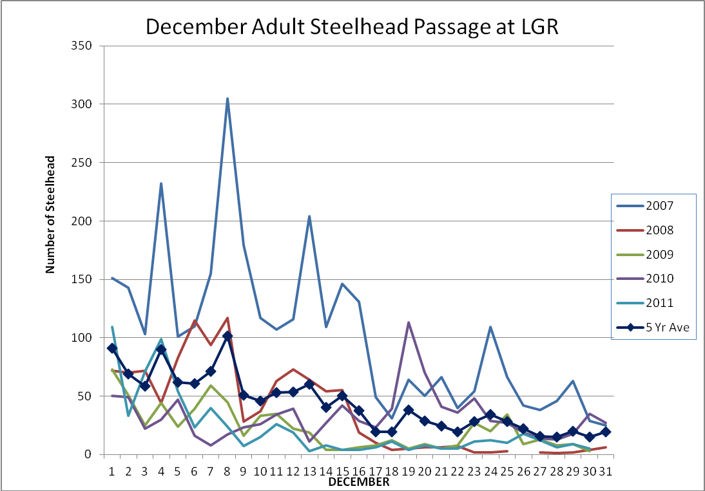

Comments from agencies
Final results
☻☻☻☻☻☻☻☻☻☻☻☻☻☻☻☻☻☻☻☻☻☻☻☻☻☻☻☻☻☻☻☻☻☻☻☻☻

